FAQs ARG
Is my business eligible for an Additional Restrictions Grant (ARG)?
The ARG scheme applies where local restrictions (LCAL3) are put in place or where a widespread national lockdown is announced. Businesses must have been trading on 4th November 2020 (the first full day before national lockdown restrictions, commonly known as ‘the second lockdown’) to be eligible to receive grant support in Round 1 and Round 2 of the ARG scheme.
In Round 2 if the applicant/business commenced trading after the 4th November 2020, they will be able to apply but will need to prove that they were trading on the day before the national restrictions for their type of business came into force.
Applications for the Additional Restriction Grant will be available on a phased basis.

Who are the ARG Round 1 grant schemes for?

Round 1 grants are for claims for the National restrictions period 5th November 2020 – 2nd December 2020 for the following business categories:

1A – Businesses that are legally required to close and have commercial premises, but that do not have Non-Domestic Rates liability.

1B – Businesses that are legally required to close and do not have commercial premises

1C – Businesses that are not legally required to close but are significantly impacted by the national restrictions – businesses with Non-Domestic Rates liability. This scheme is for businesses that mainly supply their goods and services directly into the hospitality, accommodation and leisure sectors.

1D - Businesses that are not legally required to close but are significantly impacted by the national restrictions – businesses with commercial premises but that do not have Non-Domestic Rates liability. This scheme is for businesses that mainly supply their goods and services directly into the hospitality, accommodation and leisure sectors.

1E - Businesses that are not legally required to close but are significantly impacted by the national restrictions – businesses that do not have commercial premises. This scheme is for businesses that mainly supply their goods and services directly into the hospitality, accommodation and leisure sectors.
Please refer to Dudley Council’s Additional Restrictions Grant (ARG) Policy for full eligibility criteria.

Who are the ARG Round 2 grant schemes for?
Round 2 grants are for the period of local and national restrictions 3/12/20 – 16/2/21 for the following business categories:
Grants are available for this period to businesses in the following categories:
2A – Businesses that are legally required to close and have commercial premises, but that DO NOT have a Business Rates account. (If you receive a business rates bill, even if you pay £0 due to Small Business Rate Relief do not apply for this grant).
2B – Businesses that are legally required to close and do not have commercial premises. Including market traders, peripatetic businesses (i.e. those businesses that move around) that hire multiple facilities, home-based businesses, Bed & Breakfasts that pay council tax rather than business rates
2C – Businesses that are not legally required to close but are significantly impacted by the national and/or local restrictions, have a Business Rates account AND mainly supply their goods/services directly into the hospitality, events or leisure sector.
2D - Businesses that are not legally required to close but are significantly impacted by the national and/or local restrictions – businesses with commercial premises but that do NOT have Business Rates liability AND mainly supply their goods/services directly into the hospitality, events or leisure sector.
2E - Businesses that are not legally required to close but are significantly impacted by the national and/or tier restrictions – businesses that do not have commercial premises AND mainly supply their goods/services directly into the hospitality, events or leisure sector.
In addition, this scheme also includes a single one-off payment scheme for certain specific businesses that were ineligible for the government’s ‘Christmas support payment for wet-led pubs’ grant in December 2020:
2F - Christmas grant to support community organisations, sports and social clubs, snooker halls or similar community-based social clubs which have a bar selling alcoholic beverages, and have been severely impacted by government restrictions during period 02/12/20 – 29/12/20 but were not eligible for the national Christmas Support Payment (CSP). Organisations must show that they are structured for trade (i.e. have a trading entity and structure).
Please refer to Dudley Council’s Additional Restrictions Grant (ARG) Phase 2 Policy document for full eligibility criteria for all schemes.

How do I know if my business has been forced to close?
The government has defined the types of businesses forced to closed. Health Protection Legislation of all businesses forced to close is available at The Health Protection (Coronavirus, Restrictions) (All Tiers) (England) Regulations 2020 (legislation.gov.uk).

What are fixed business-related costs?
Fixed business-related costs are ongoing, regular payments that a business has to pay independent of any specific business activities. I.e. it doesn’t not change with an increase or decrease in the number of products/services produced or sold.
Examples include: Building insurance, contents insurance, credit or loan statement in the name of the business, employer’s liability insurance, indemnity insurance, utility bill, business mobile phone bill, mortgage document, title deeds, rent statement.

What are fixed commercial property costs?
Fixed commercial property costs are ongoing, regular payments that a business has to pay for a commercial property from which they operate their business from.
Examples include: Building insurance, Utility bill – such as electricity, gas, water, landline phone, commercial mortgage documents, lease agreement, rent statement, other insurance for the building.

What do I need to provide for proof of trading?
You will need to provide proof that your business was actively trading on the day before the restrictions relevant to your business came into effect. For example, a pub has been closed since the restrictions came in on 5/11/20 so would need to evidence trading on 4/11/20. It must be from just before the restrictions started and not during the restrictions.
Examples of evidence include: Sales receipt, expenses receipt, purchase order, delivery note.

I am a self-employed business, am I eligible for this fund?
Yes. Self-employed businesses who meet the criteria set out in our policy are eligible to apply.
Please note this scheme is not intended to pay employee wages, it is to support businesses with significant fixed costs.
To find out what other financial support may be available for you and your business visit the Business Coronavirus Support Finder.

Can voluntary and/or community business-based organisations apply to the ARG grant scheme?
Voluntary and/or community business-based organisations can apply to ARG Round 2 grant schemes if they meet the full scheme criteria and, in addition, have a business bank account together with a legal structure that matches the listed eligible structures:
- Unincorporated association
- Trust
- Partnership
- Company Ltd by Shares (CLS)
- Company Ltd by Guarantee (CLG)
- Charitable Incorporated Organisation (CIO)
- Community Interest Company, limited by shares (CIC – CLS)
- Community Interest Company, limited by guarantee (CIC – CLG)
- Limited Liability Partnership
- Co-operative Society (previously IPS); and
- Community Benefit Society (CBS)
Please refer to Dudley Council’s Additional Restrictions Grant (ARG) Phase 2 Policy document for full eligibility criteria for all schemes.

My business gets small business rate relief; am I eligible for ARG?
If you get Small Business Rates Relief it means that you are a business rates payer for these purposes; it’s just that you’re a business rates payer who gets a bill for £0.
If you are a business rates payer (or get Small Business Rates Relief) and have been forced, by law to close under the national and or local restrictions you will need to apply for the National Restrictions Grants and/or the Business Support package schemes for the period(s) of closure. Details of these schemes and eligibility can be found here: https://www.dudleybusinessfirst.org.uk/coronavirus-business-guidance/financial-help-for-businesses/
If you are a business rates payer (or get Small Business Rates Relief) and have not been legally forced to close but are significantly impacted and mainly supply your goods and services directly into the hospitality, events or leisure sectors you may be eligible for ARG 1C and/or ARG 2C.

Is there a closing date for applications?
Yes – for Round 1 of the Additional Restrictions Grant, all applications must be submitted by 11.59 on 31st January 2021. The Round 1 scheme will then be closed.
Yes – for Round 2 of the Additional Restrictions Grant, all applications must be submitted by 11.59 on 31st March 2021. The Round 2 scheme will then be closed.

I previously received a grant, will I automatically receive a payment or do I need to submit a new application?
These grants are not automatically granted. All businesses are required to confirm that they are eligible to receive the Additional Restrictions Grant, therefore you must submit a new application. You must also complete a new application for each round of funding released due to changes in schemes and/or declarations.
If you have already applied for ARG Round 1 you will be able to autofill your application for ARG round 2 on the portal. If you do this, please ensure that you update any details that have changed and upload any additional evidence. You will need to reconfirm your eligibility for the Round 2 grant.
Please also note that the ARG funding is separate to the Small Business Grant, Discretionary Grant Fund or Retail, Hospitality and Leisure Grant schemes that operated in March-August 2020 and has different eligibility criteria.

How much money could my business get?
Awarding of grants will be at the Council’s discretion, in line with the Dudley Council ARG policy AND specified BEIS eligibility criteria.
Round 1.
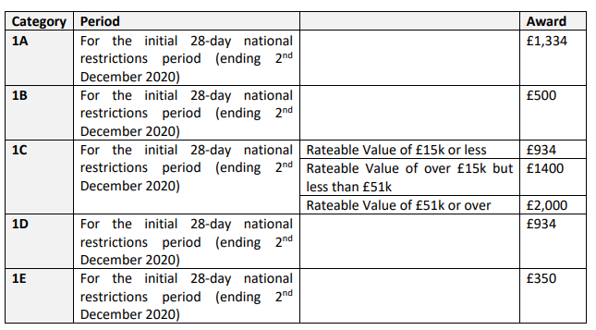
Round 2.
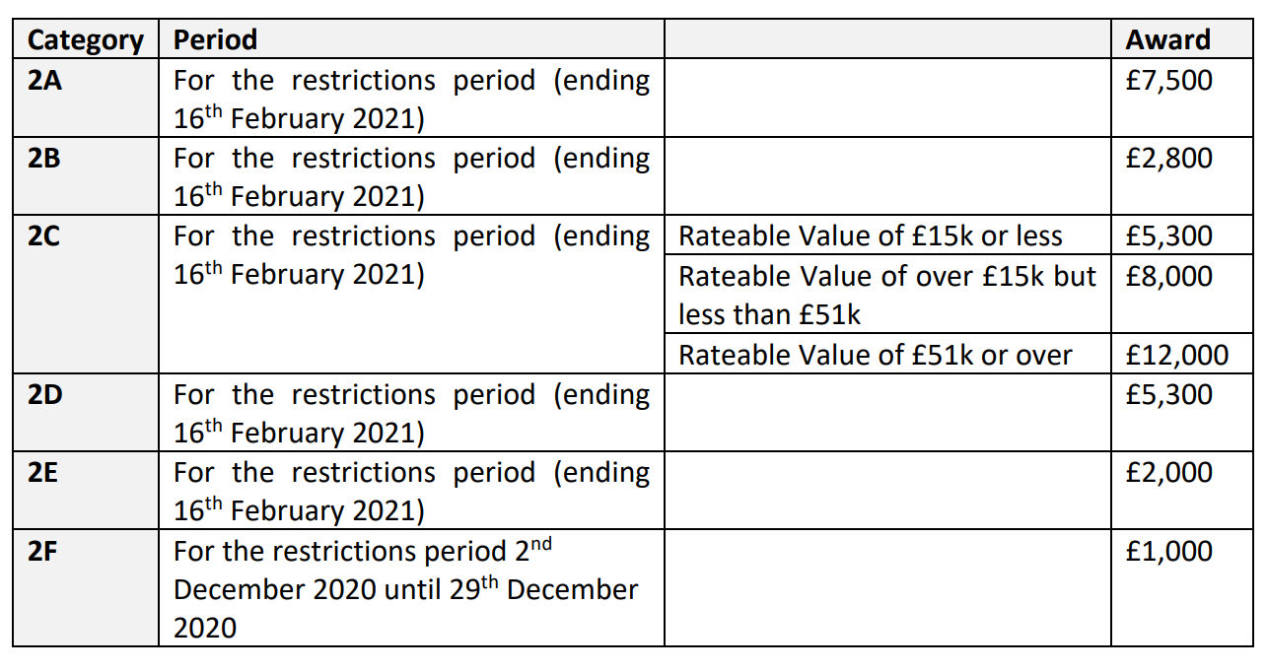

How long will it take to receive my grant payment?
We are working hard to support businesses as quickly as possible. A decision will be made as soon as practicable after an application is received. In order for us to process applications as quickly as possible, please do not chase your application but log-in and check your status on the self-serve grant approval portal (the website where you went to apply for your grant).
We will also be using the grant approval portal to communicate with you if any further information is required to support your application. Any communication will be via the comments function. Please communicate with us via this portal. This is the most secure way for you to get in touch and is for your own financial safety and security.
Could you give me some examples of businesses who may be eligible for the ARG?
The examples below are subject to the applicant meeting all of the other eligibility criteria for the category in which they are applying.
- A non-essential retailer without rates liability but pays a business rates contribution or commercial rent to their landlord may find that they are eligible under ARG 2A
- A mobile hairdresser who doesn’t have a business premises but hires a commercial vehicle may find that they are eligible under ARG 2B
- A commercial caterer operating from an industrial premise for which they have the business rates liability may find themselves to be eligible under ARG 2C
- An event production company that rents warehouse space from a larger company for a single all-inclusive rental fee may find themselves eligible under ARG 2D
- A wedding planning company working from home with professional liability insurance costs may find themselves to be eligible under ARG 2E
- A community-based sports and social club with a bar may be eligible under ARG 2F.

What happens if I have applied but entered my bank details incorrectly?
Unfortunately, we are unable to amend your bank details for your financial protection, if you have manually entered your bank details incorrectly you will need to complete a new application.

What happens if I apply for the wrong grant scheme?
Your application can only be considered against the criteria set for the scheme you have applied for. The first stage of the application process will guide you to self-declare against the eligibility criteria. This will help you to ensure that you are applying for the correct scheme. If you want to change the scheme you are applying for you will need to complete a new application for the relevant scheme.
Applications are non-transferrable.

Who can claim the grant?
In all cases Government has stated that the person who will receive the grant will be the person who, according to the Council’s records, was the ratepayer in respect of the hereditament at the effective date.
Where there is no entry in the rating list for the business, the Council will have discretion to determine who should receive the grant.

Can the council claim back the money?
As an applicant you must provide true, accurate information when applying for the grant. If it is established that any award has been made incorrectly due to error, misrepresentation or incorrect information provided to the Council by an applicant or their representative(s) the council reserves the right to recover any grant paid in full.
This matter is mentioned frequently throughout the grant application process, and you must sign to state that you understand this when applying for a grant.

If I am not happy with a decision can I appeal?
There is no appeals process for this scheme.
The Council’s formal ‘Complaints Procedure’ will be applied in the event of any complaint received about this scheme. https://www.dudley.gov.uk/council-community/compliments-comments-complaints/

Is the grant subject to Tax?
The Government has confirmed that all payments under the scheme are taxable.

What do ‘in administration’, ‘insolvent’ and ‘striking off notice’ mean?
Please visit https://www.gov.uk/government/publications/liquidation-and-insolvency/liquidation-and-insolvency for more information.

What is State Aid and does it apply to this grant?
The Additional Restrictions Grant (ARG) is a grant provided by a public authority, therefore it is subject to State Aid rules.
Any grant is given as aid under the Temporary Framework for State Aid measures to support the economy in the current COVID-19 outbreak published on 19 March 2020. This means that businesses receiving support under these provisions can receive up to €800,000 in aid over three years (being the current and previous two years).
In compliance with EU law on State Aid the applicant will need to declare to the Council if the have received any other de minimus State Aid or aid provided under the EU Commission COVID-19 Temporary Framework.
I have a question about the Local Restrictions Support Grant (LRSG), can you help?
Dudley Council’s Business Rates team is administering the LRSG (Closed) grants and other mandatory schemes. If your question is in relation to this scheme and not the ARG scheme please view eligibility and criteria for this scheme here. If you still have questions or queries please contact them direct on 0300 555 8000 or businessratesgrants@dudley.gov.uk.

The grant approval portal is not accepting my business rates details, can you help?
Please ensure you are entering the Property Reference Number and not your Business Rates Account Number. The Property reference number can be found on the left-hand side of the main section on your business rates bill, above the property address.

I am struggling with completing my application, where can I go for further help?
Due to current high volumes of calls, and to ensure we can process applications as quickly as possible please contact us via email on discretionary.grant@dudley.gov.uk
Please be aware that we receive a high volume of enquiries, so we will get back to you as soon as possible. Please be patient.
Do I have to apply online?
Yes. All applications must be made via the self-serve online portal, unfortunately applications cannot be made in any other format.
If you do struggle with ICT, it is permissible for an applicant’s intermediary to apply on their behalf (i.e. Accountant or similar).

